Assignment 13

1. 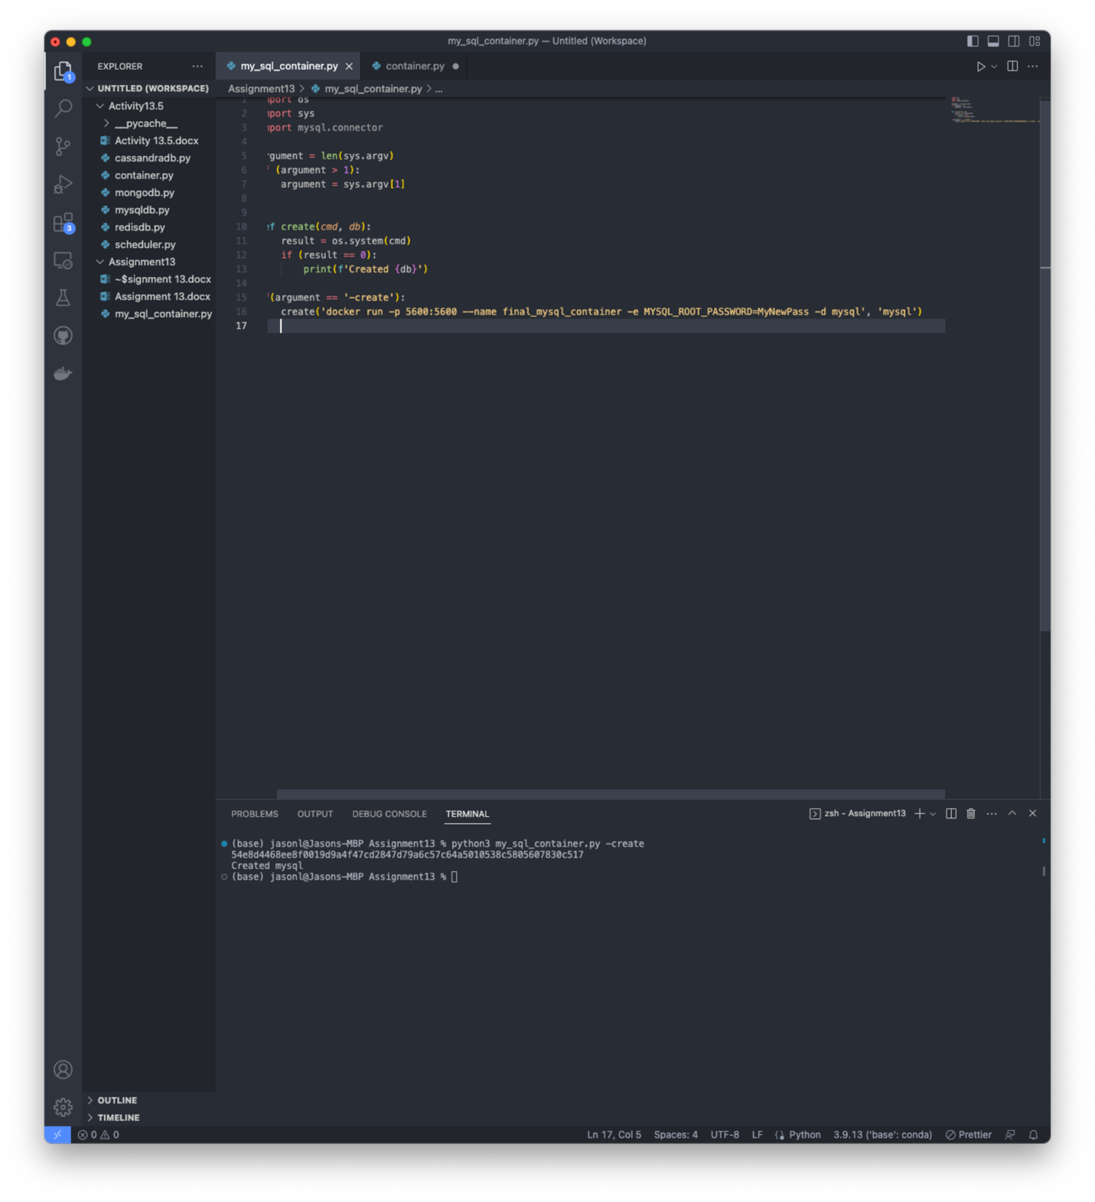
   1. Screenshot showing the correct folder name and file in my workspace. Added code to create a mysql container as per instructions.
2. 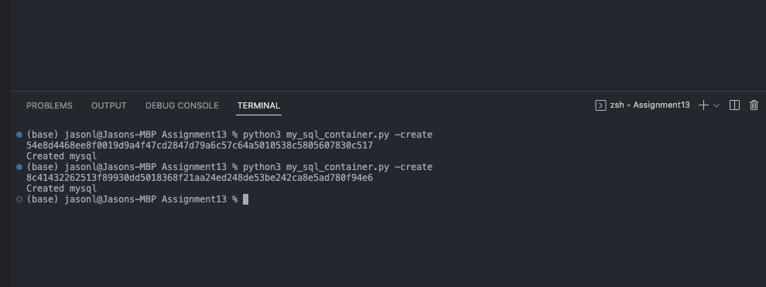
   1. Successfully creates the database container.
   2. 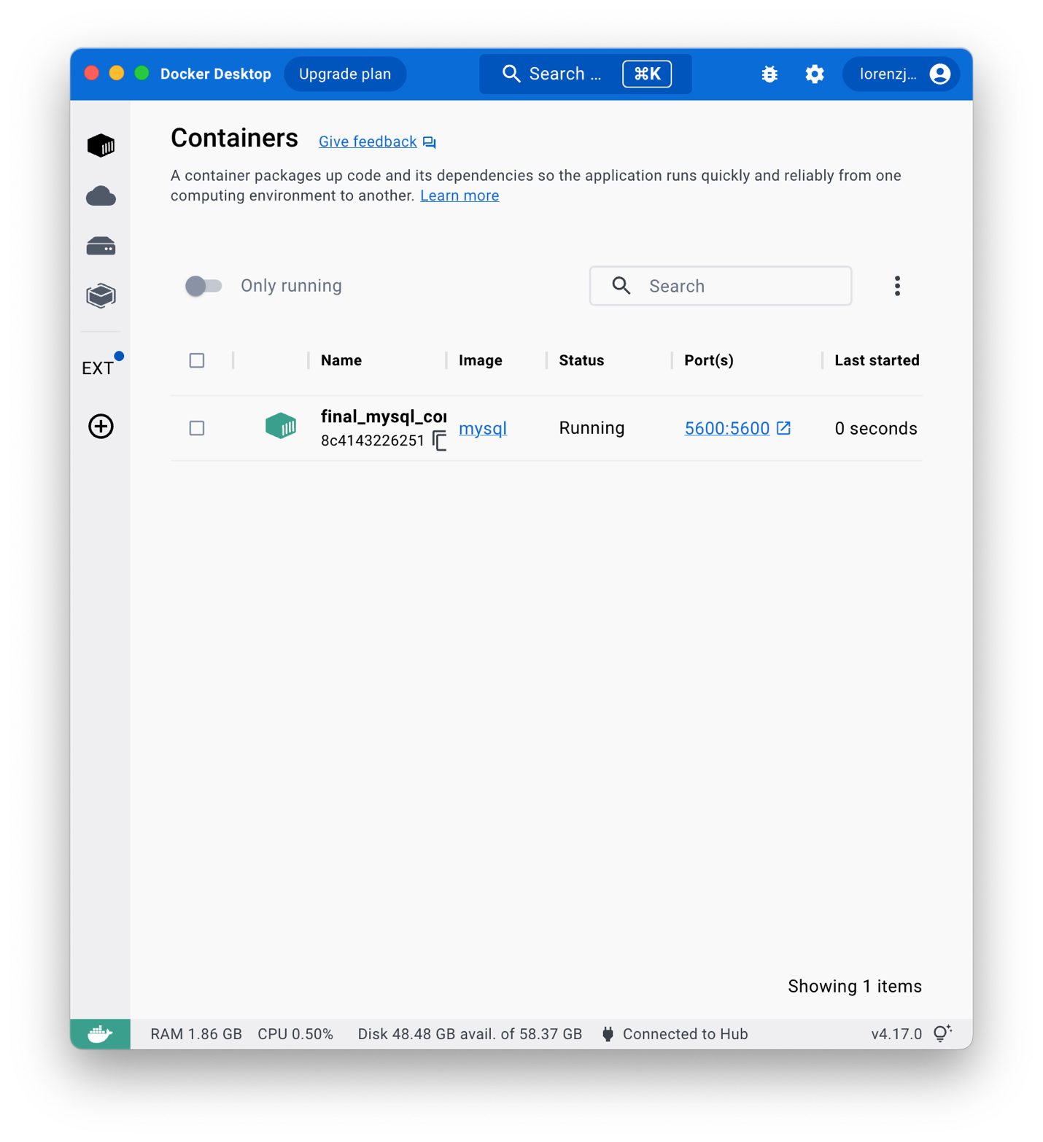
3. 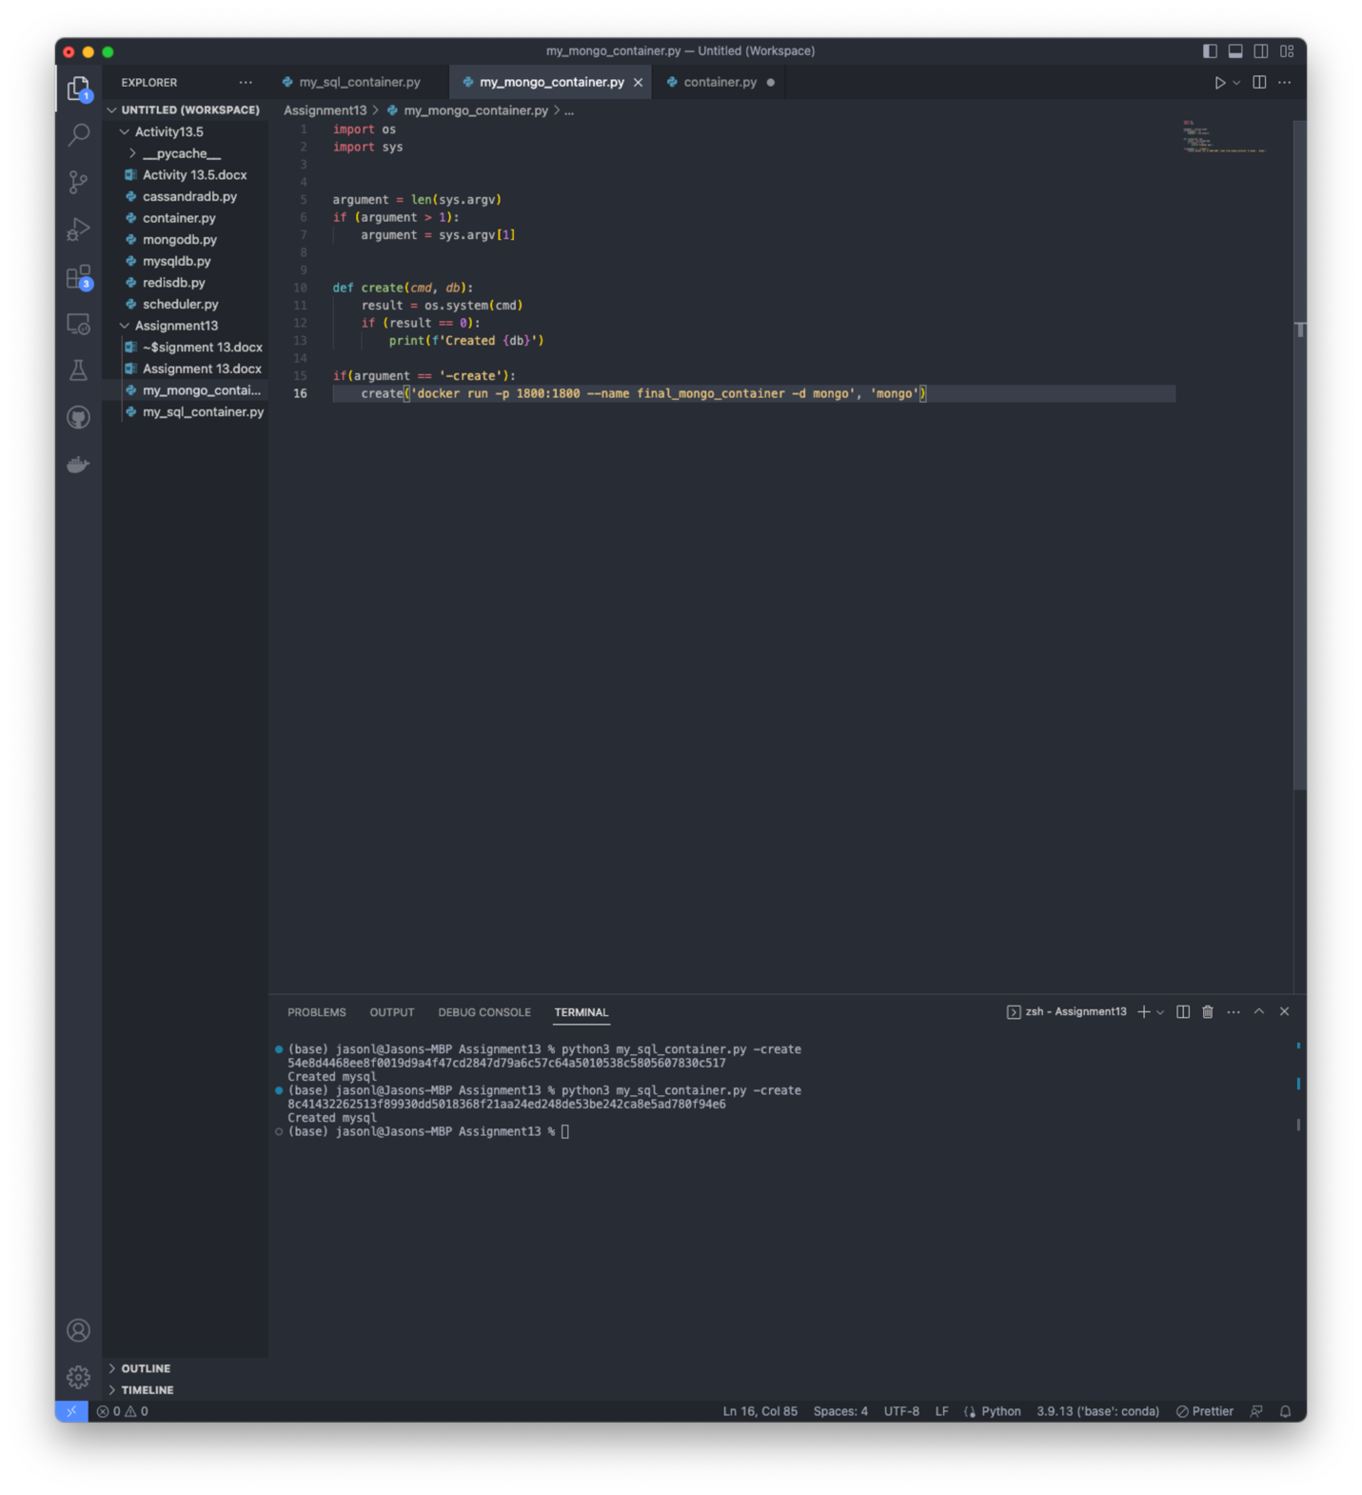
   1. Added new file and code to create a mongodb container as per instructions.
   2. 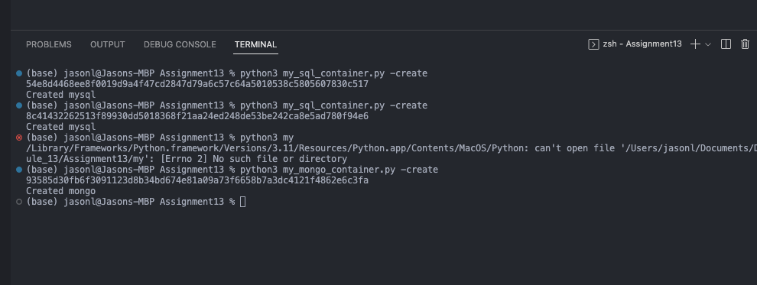
   3. 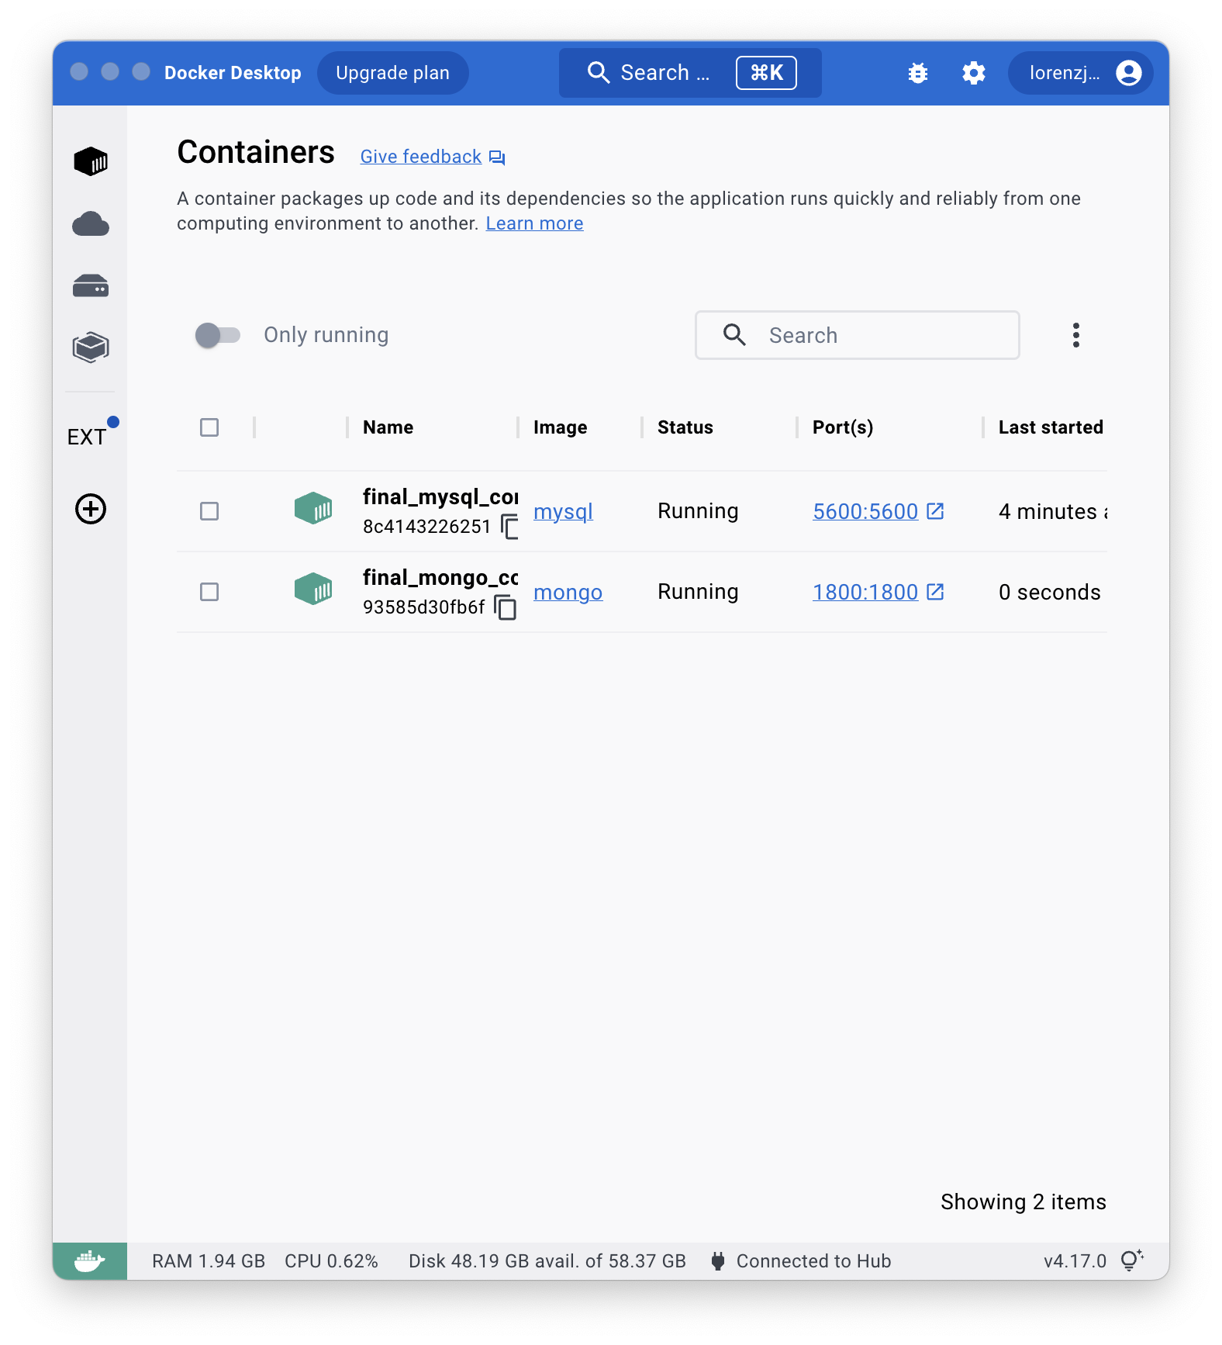
4. 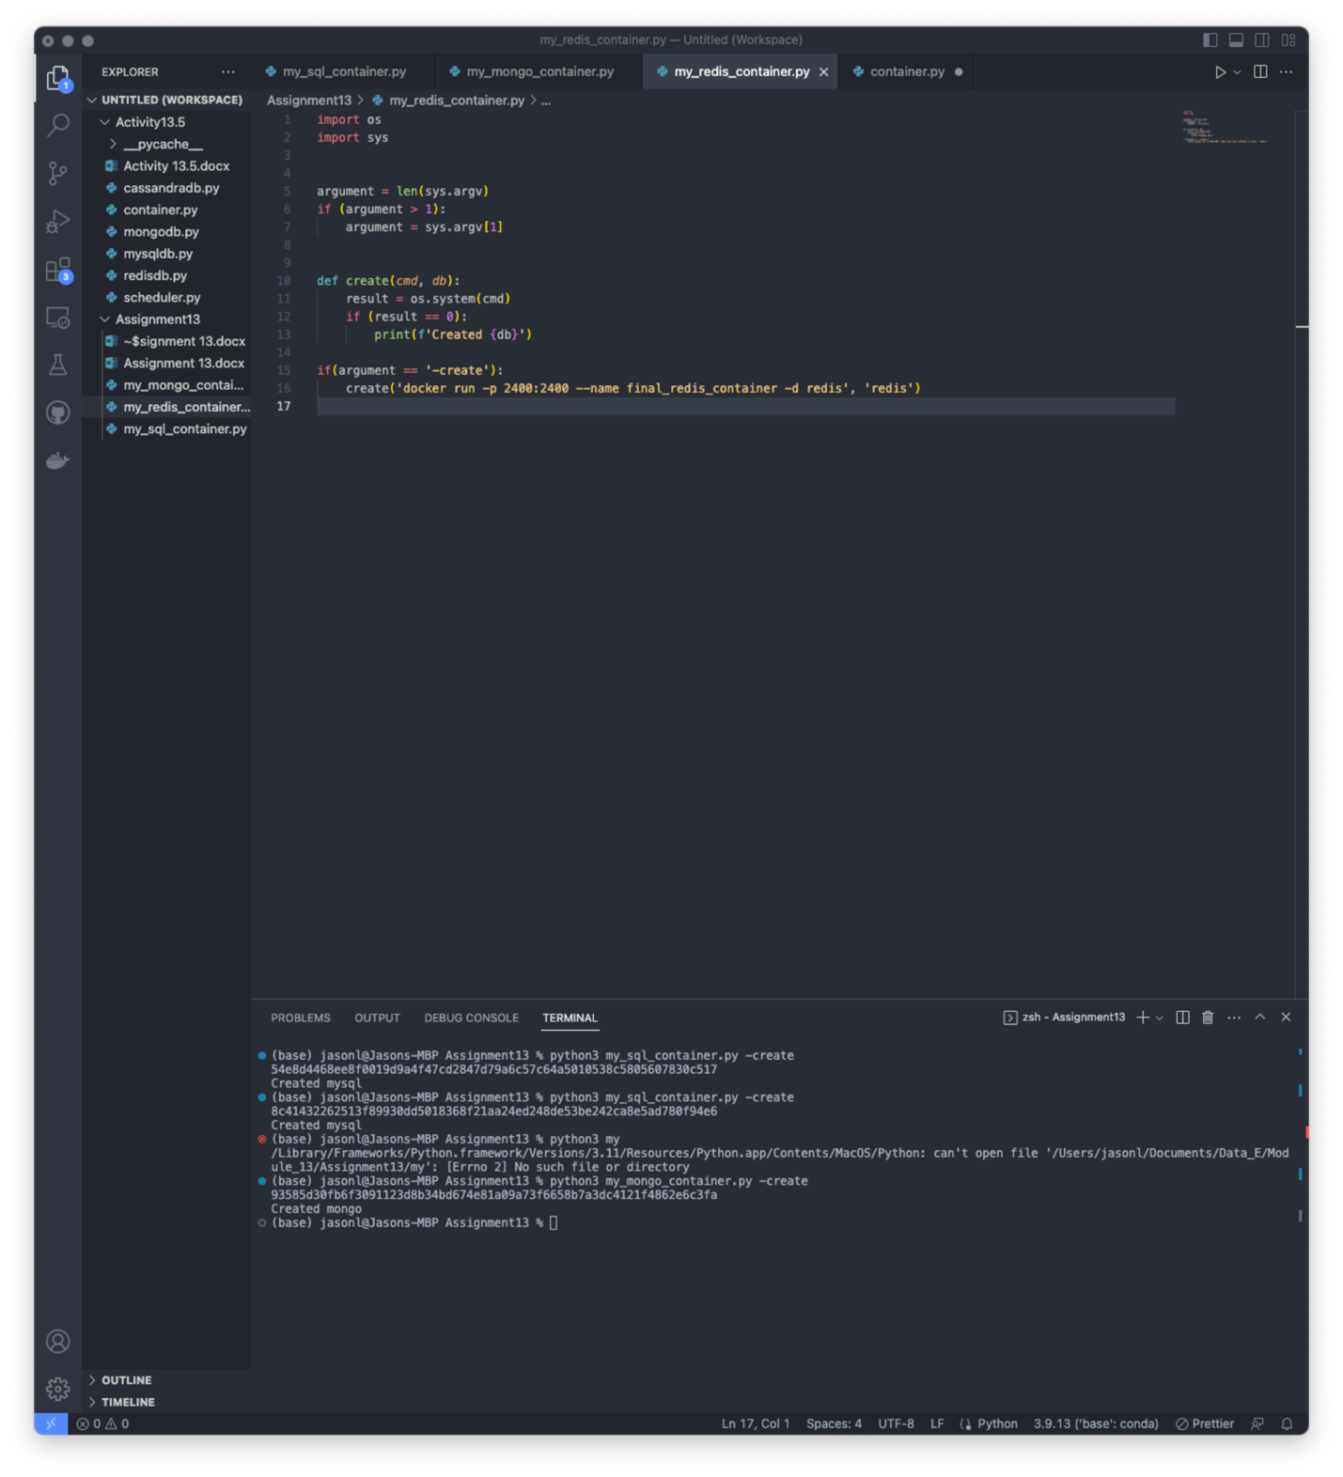
   1. Successfully created a new file with the commands to create a redis container.
   2. 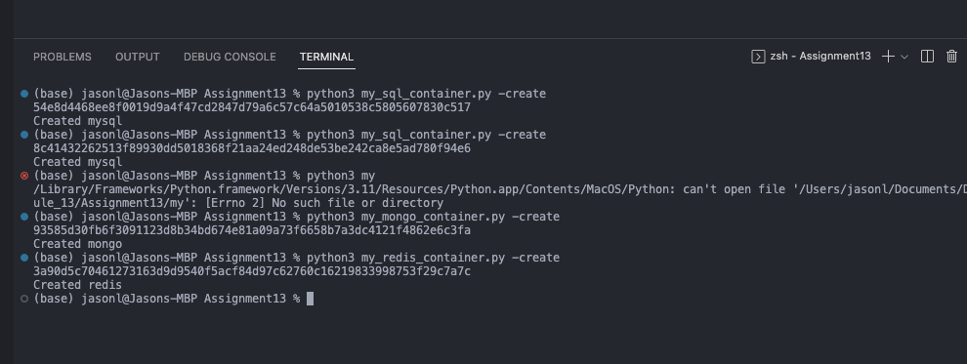
   3. 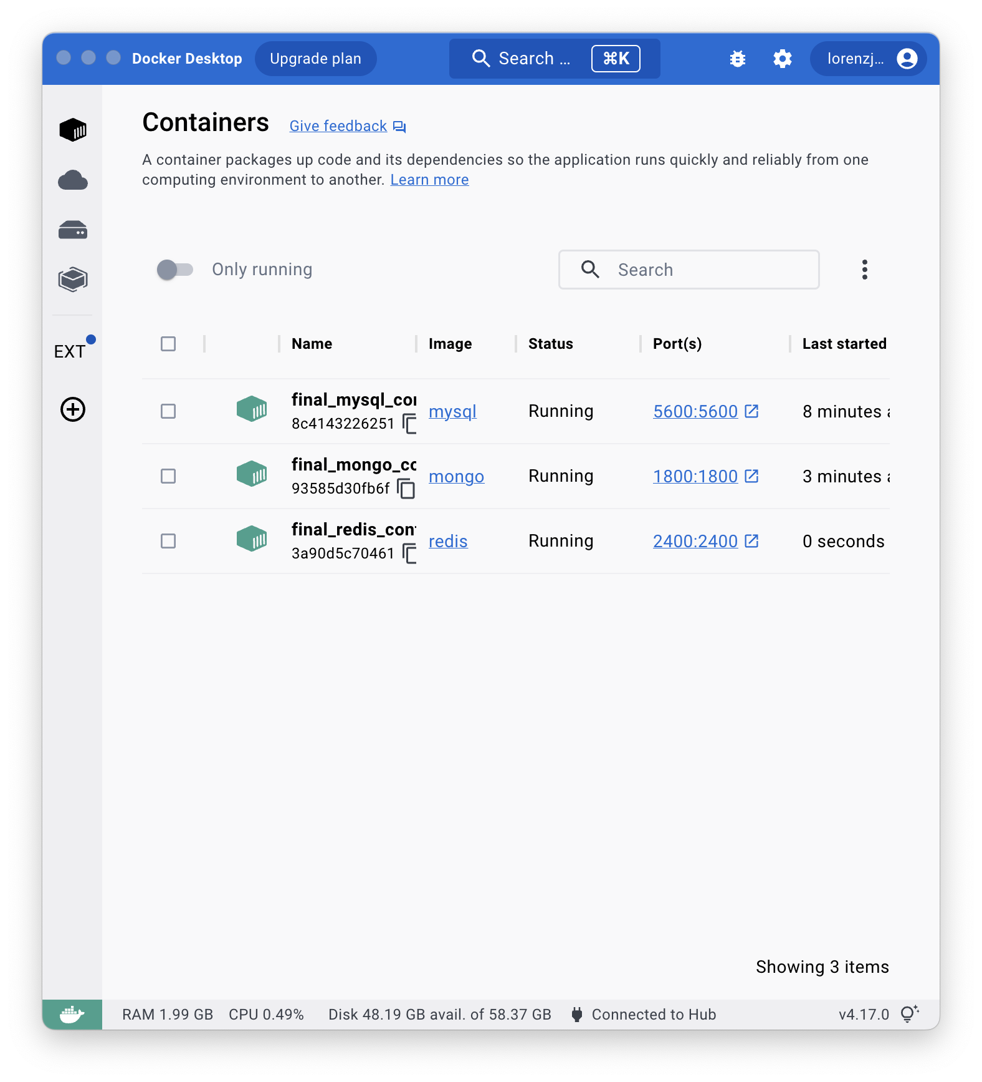
5. 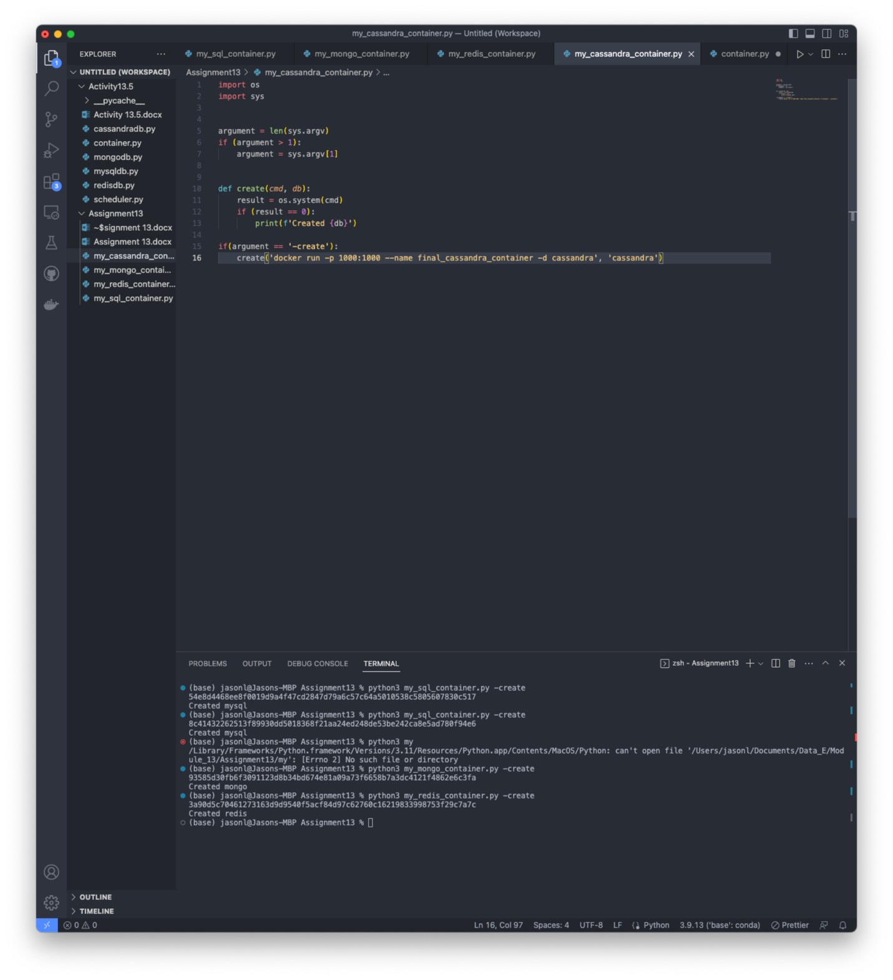
   1. Successfully created the file and input the right code to make a Cassandra container following the instructions.
   2. 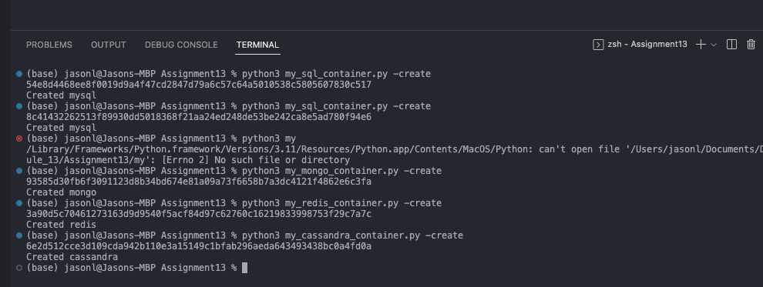
   3. 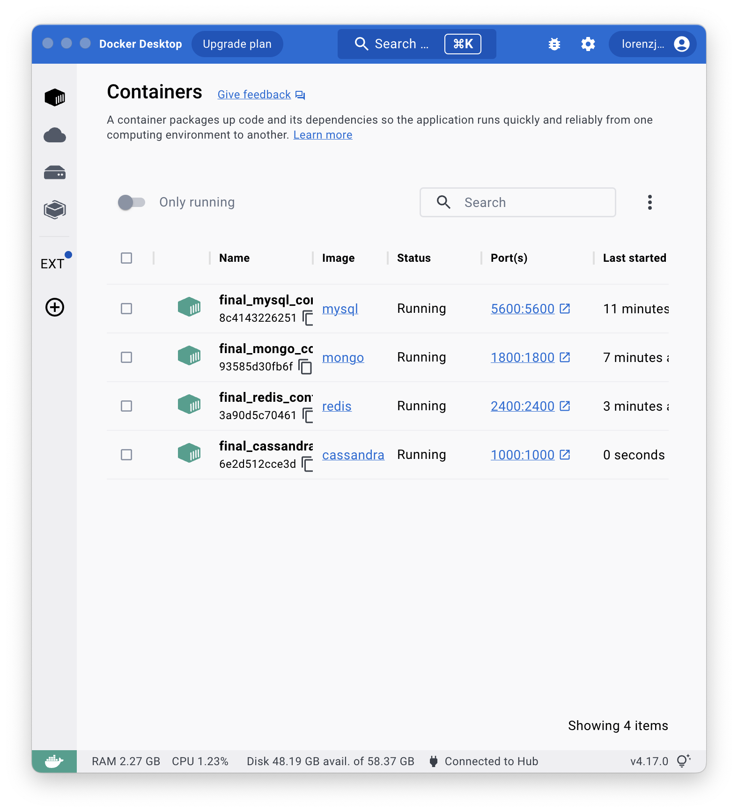
6. 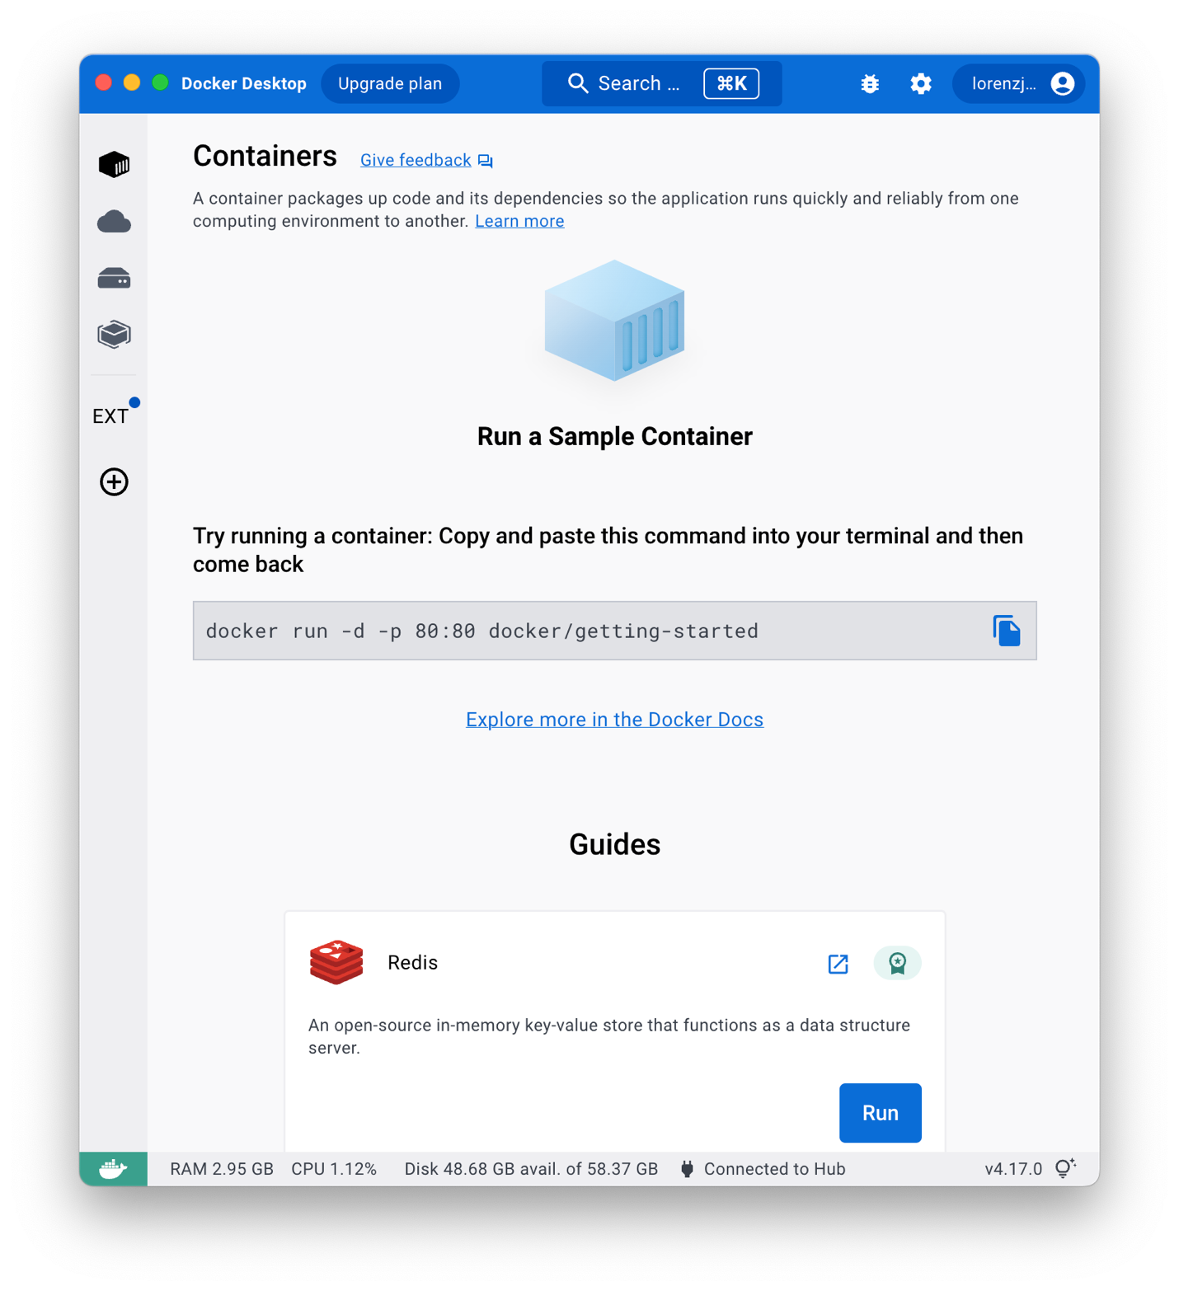
   1. Successfully deleted all containers.
7. 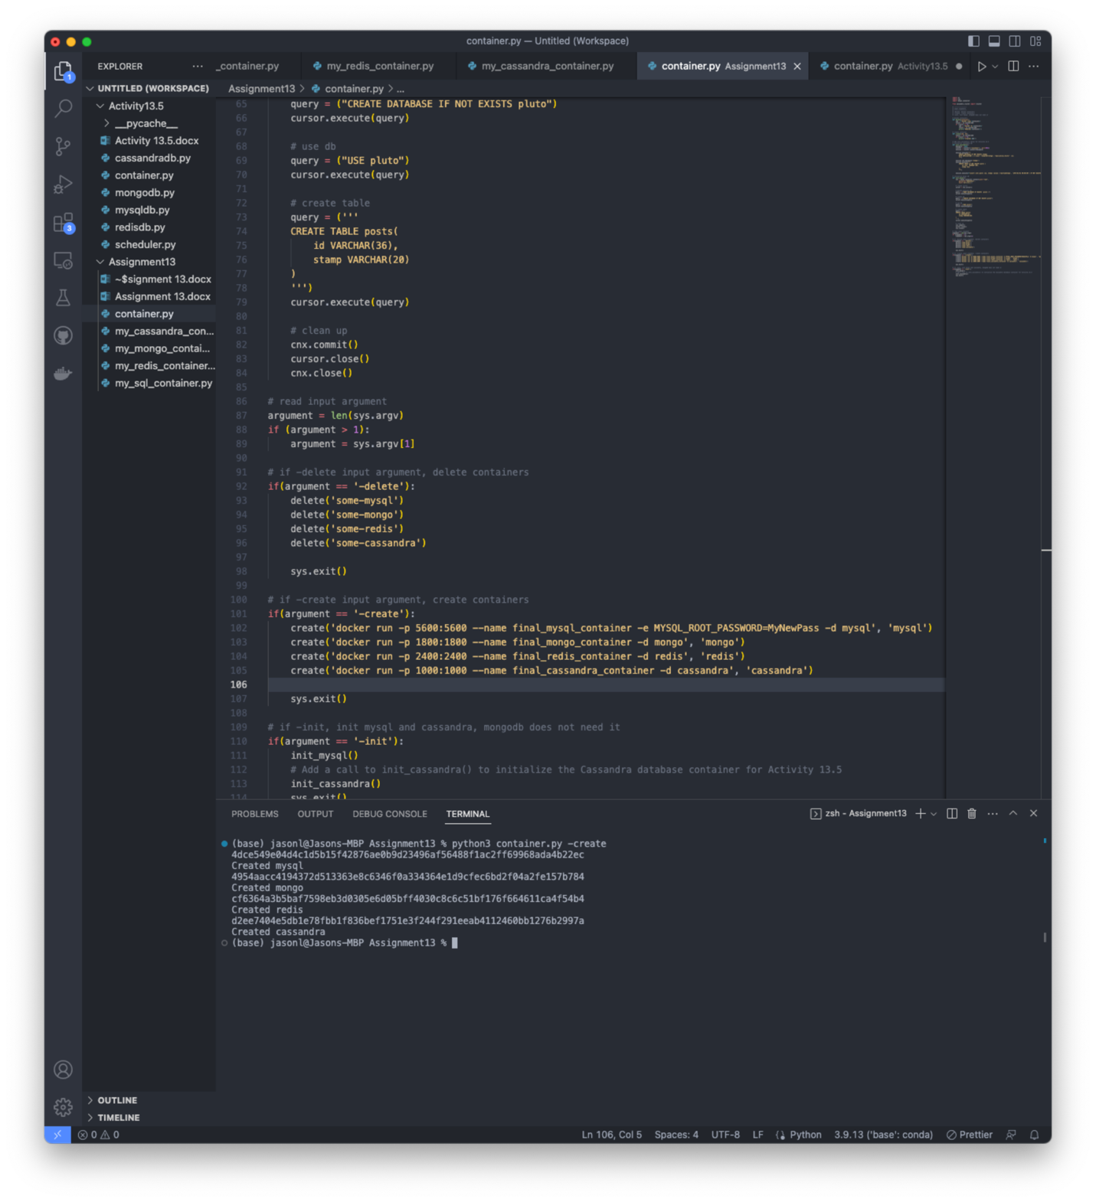
   1. I took my work from the previous activities in this module and changed the create function to create the containers as specified in part 1.
8. 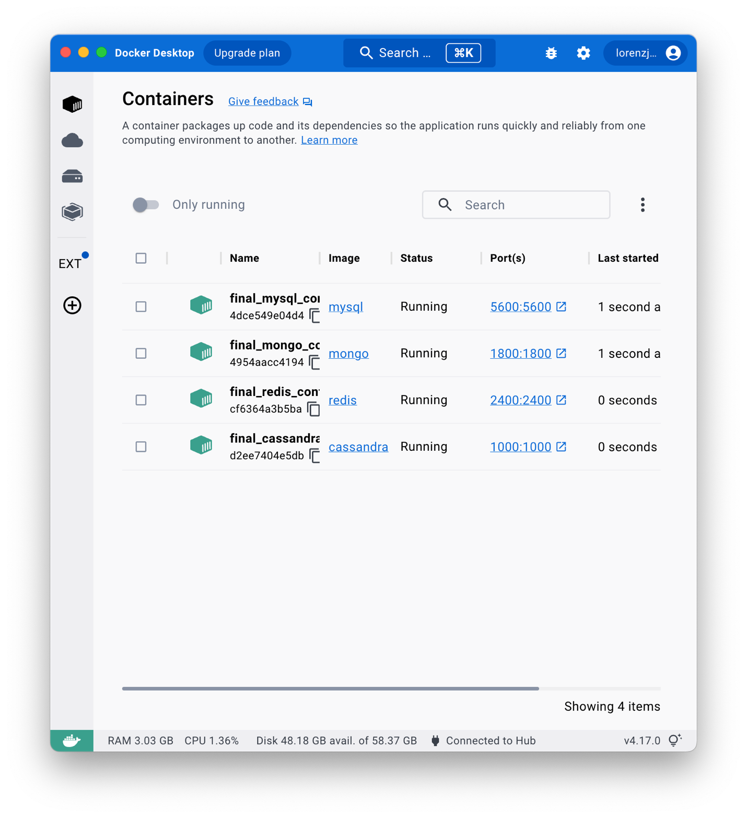
   1. All database containers have been created in docker.
9. 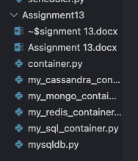
   1. File has been added to the folder.
10. 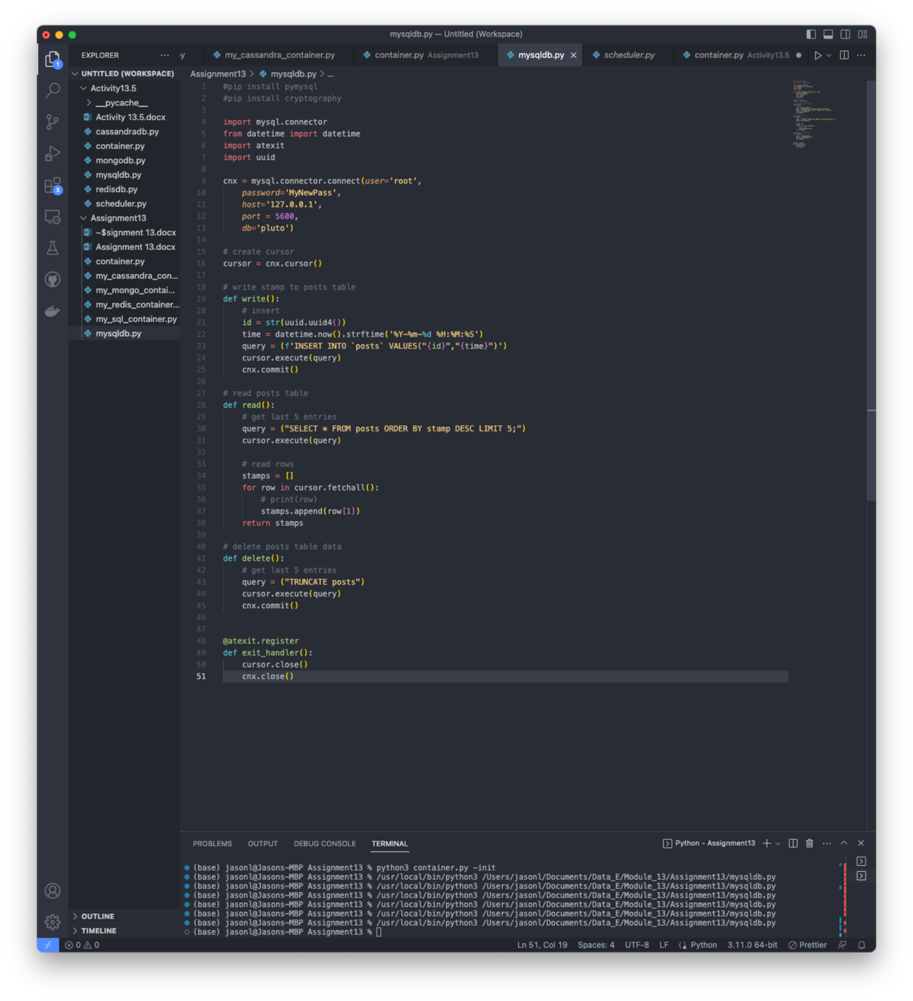
    1. Was able to successfully initialize the database and get the mysqldb.py file to run a few times. I needed to first change the create command to 5600:3306 first because docker natively looks at port 3306.
11. 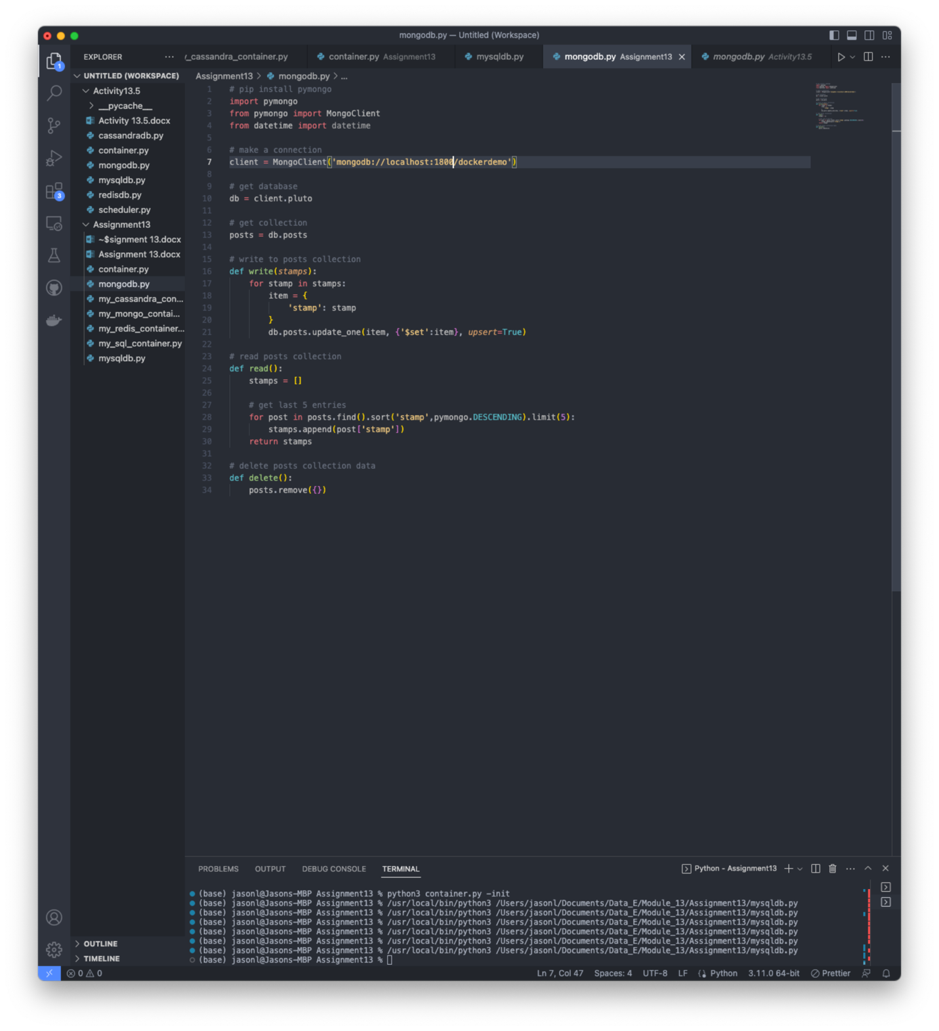
    1. Mongodb.py file created successfully.
12. 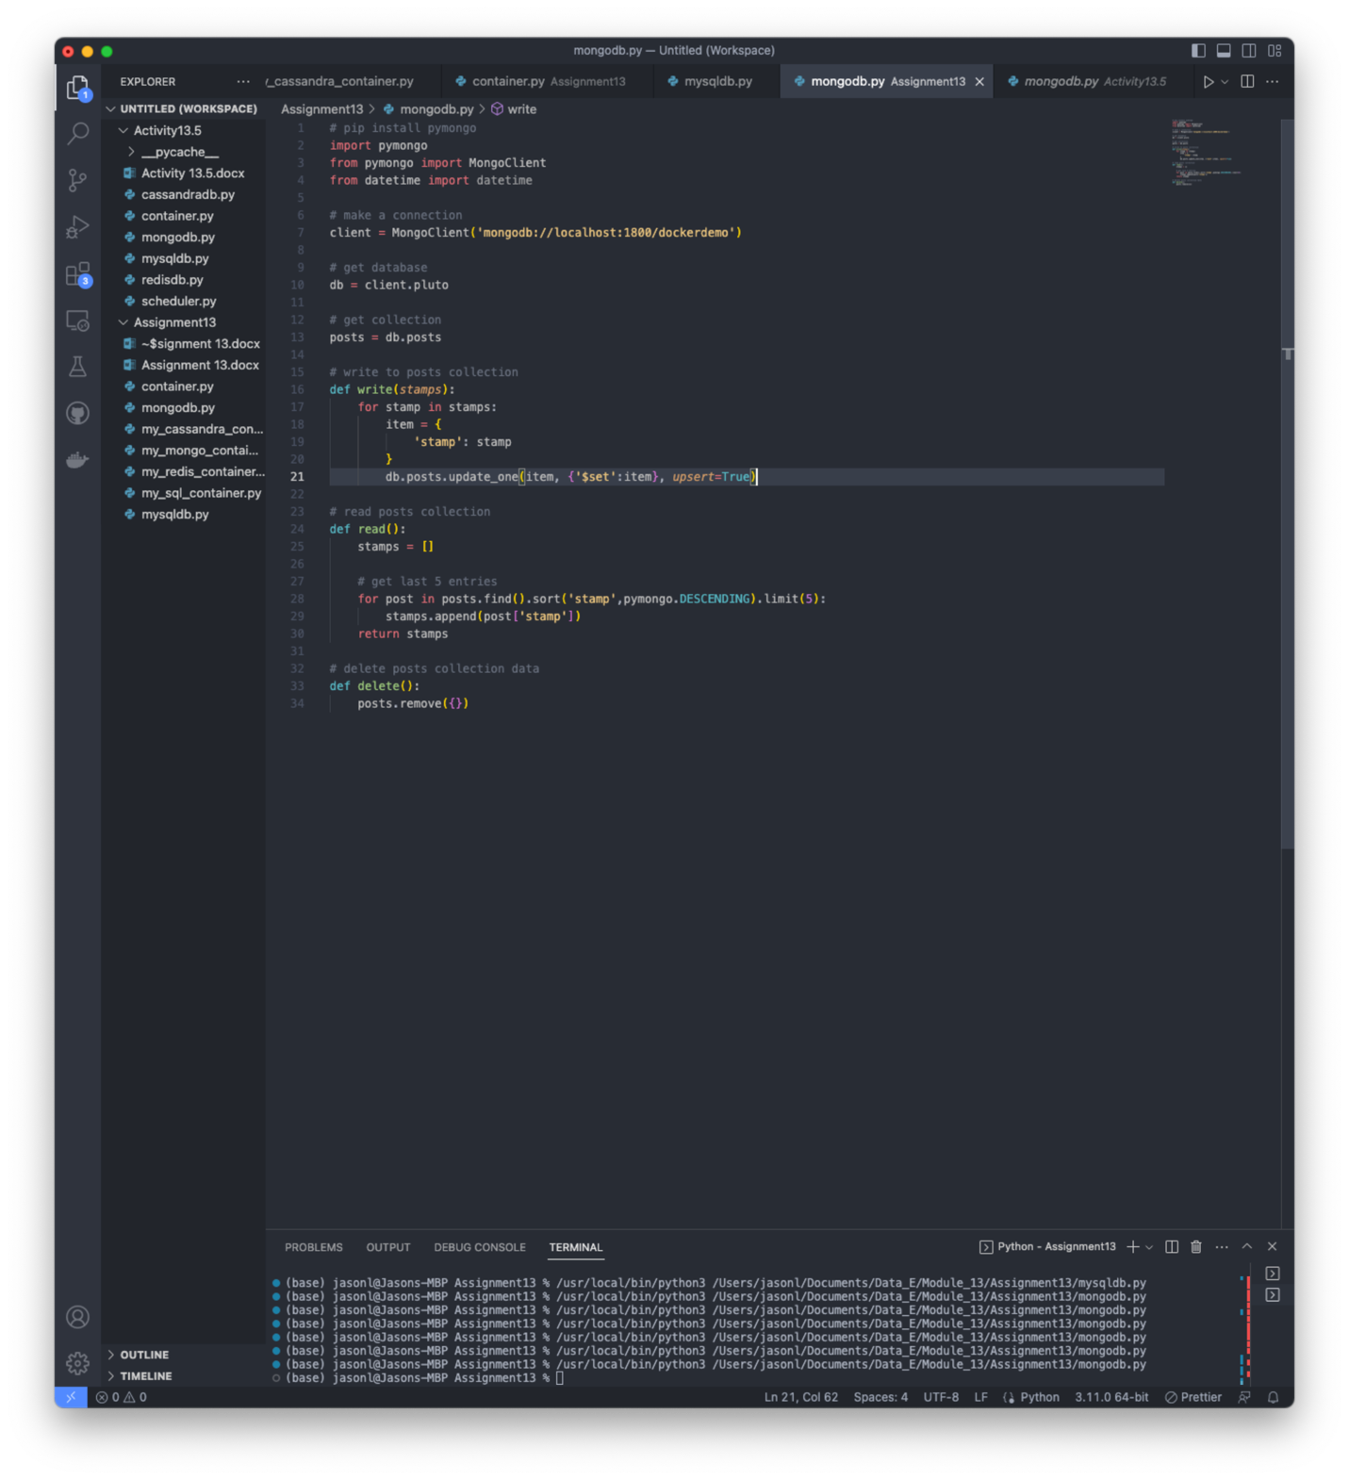
    1. You can see in the terminal that I was able to run the file a few times successfully.
13. 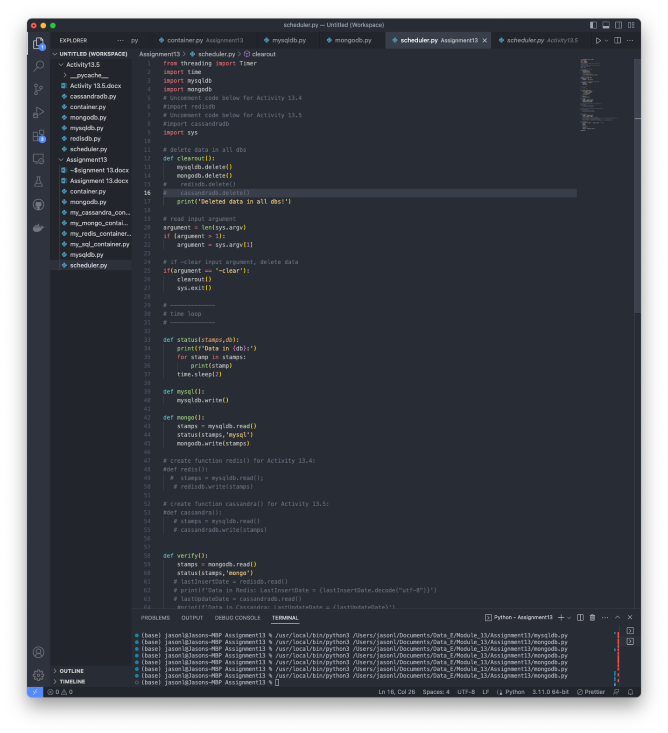
    1. I took the scheduler file from the last activity and modified it to only see the mysql and mongodb containers that I am creating for this activity. It follows the same functions as before.
14. 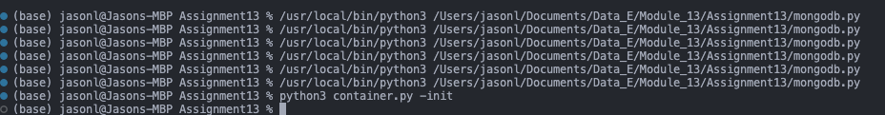
    1. Was able to successfully initialize the mysql container.
15. 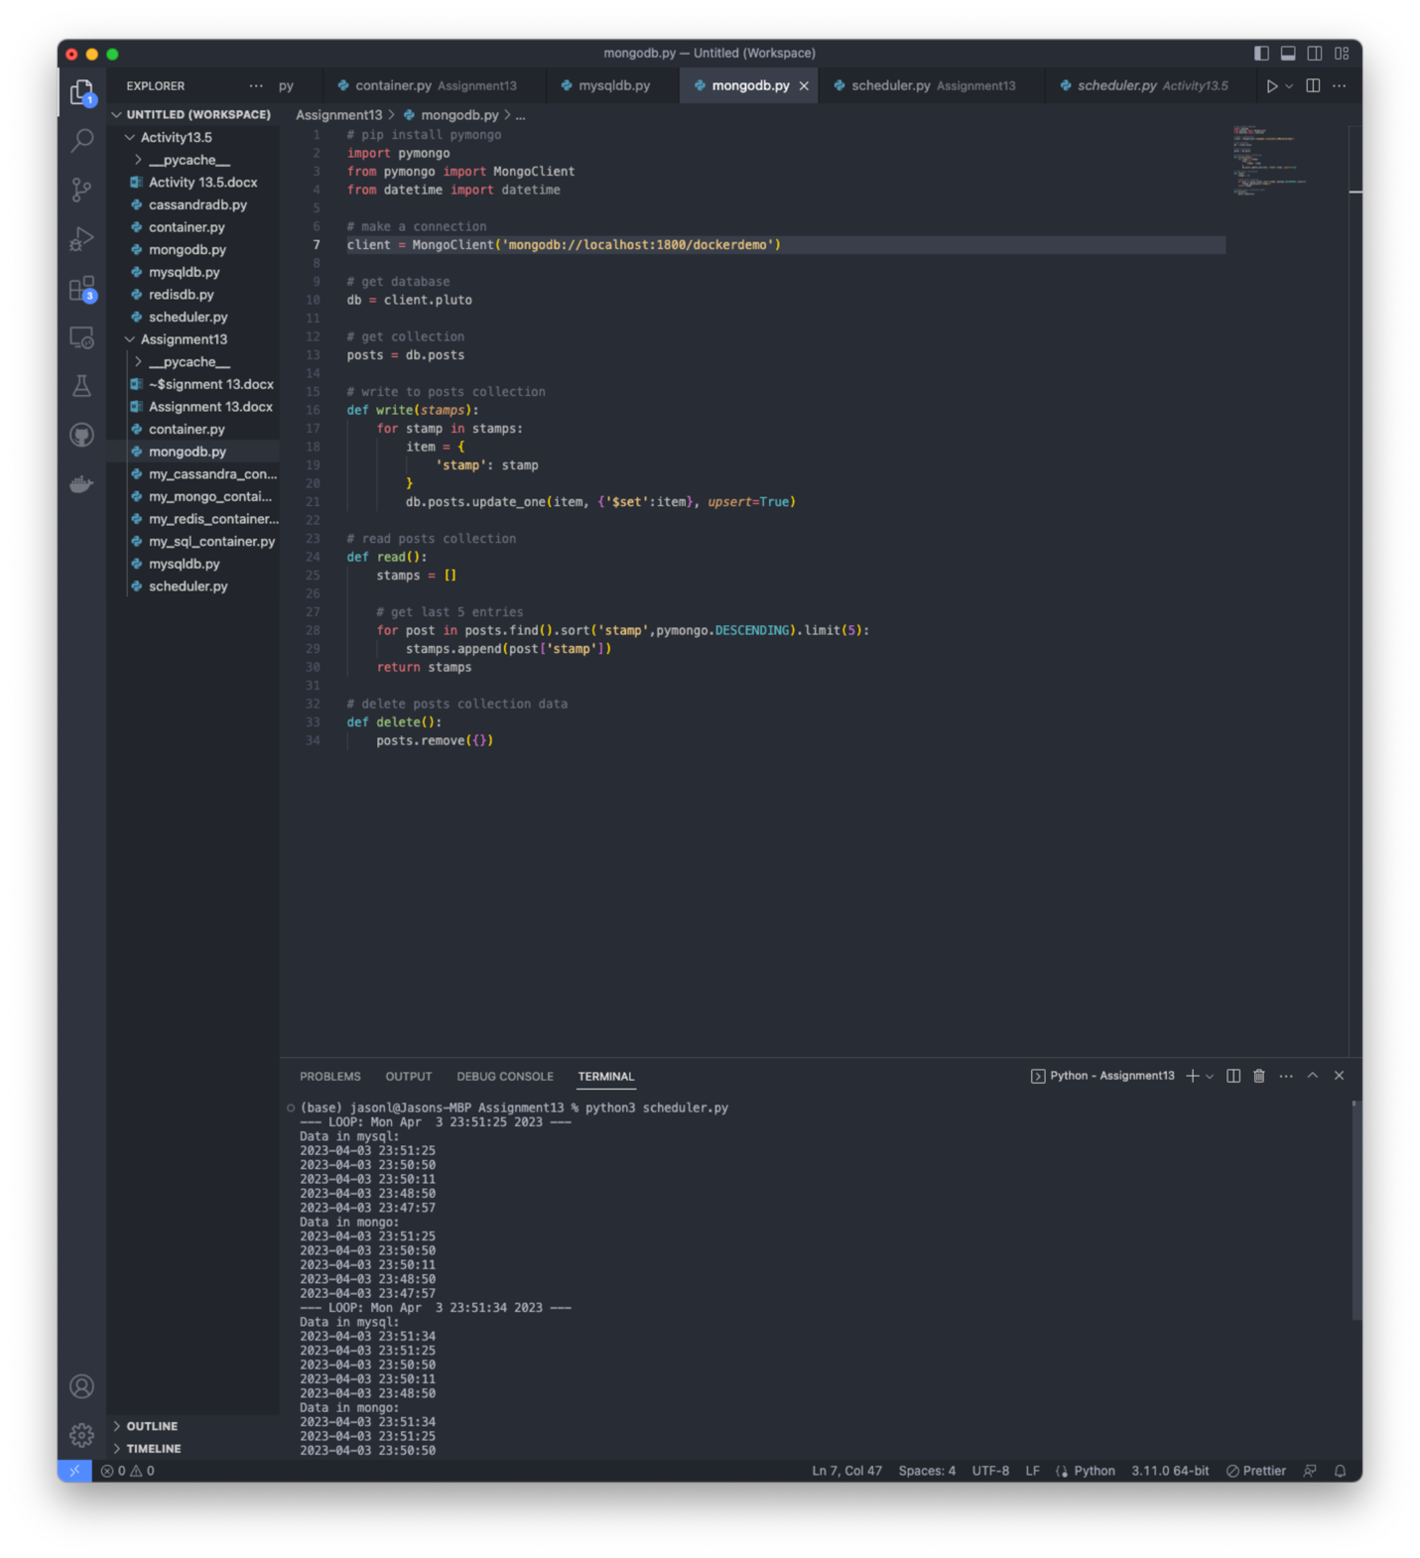
    1. Was able to successfully run the scheduler and receive data back from the databases.